Chapter 5. Design and Implementation

The Mind Bloom Application follows the Model-View-Controller (MVC) Architecture. The MVC architecture splits the implementation into three main interconnected logical components. Each of these components is built to handle specific development aspects of the application.

5.1 Database

The database used in the MindBloom Application is MongoDB. To manage the database and validate the operations performed, we used MongoDB Compass, an interactive tool for analyzing the data.

Mongoose is a third-party library for MongoDB, also said an Object Data Modeling (ODM), that helps in easy access of the data (Figure.

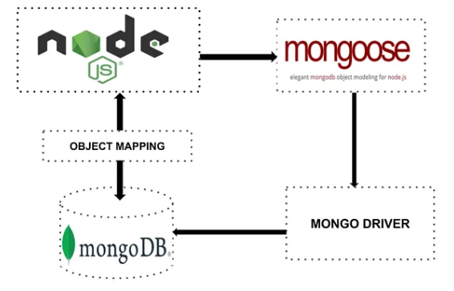

Figure 5.1 Mongoose library

To connect to the database, we use the mongoose.connect() function to which we provided the MongoDB connection URL as an argument, as shown in the Figure5.1.

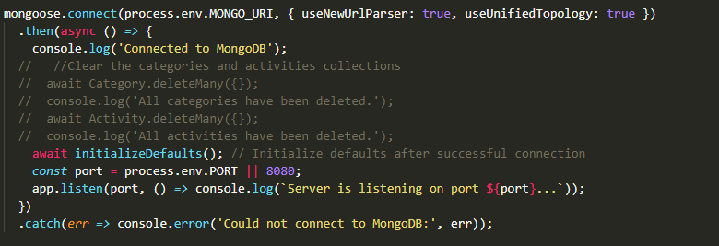

Figure 5.2. Connection to the database

5.2 Model

The model components correspond to all the data-related logic that the user interacts with. they respond to instructions from the controller to update itself. In MindBloom Application, the models correspond to the schemas from the database.

As the main actors of the application are the users, we created a user schema with user information related fields. (Figure 5.2). It is important to specify that mongoose.model() function is used to create the model with a schema as the second parameter.

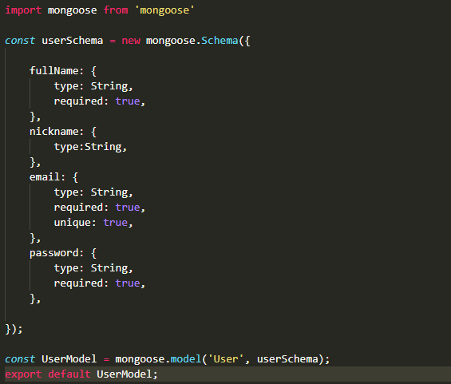

Figure 5.3. User Schema

In the same manner, we created schemas for moods, categories, activities, entries, jornal, and note, presented in the Class Diagram in Figure 5.4.

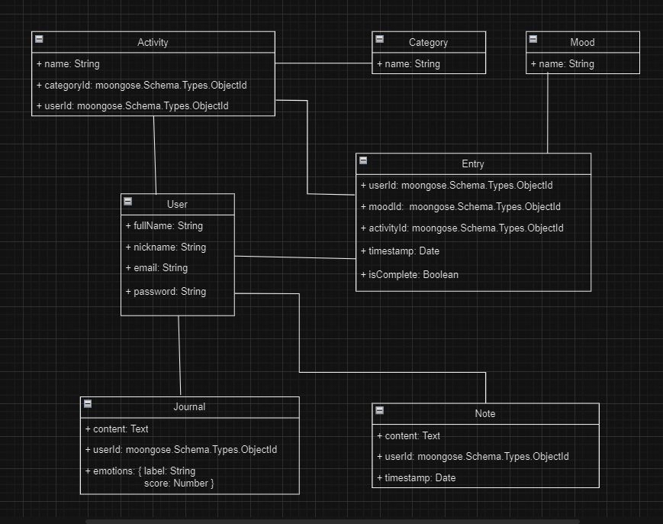

Figure 5.4 Class Diagram

5.2 Controller and Routing

The controller is the component that facilitates interconnection between the view and the model.

5.3 Handlers

5.3 View